**Ahmad Shawqi احمد شوقي** (b. Cairo, 1868- d. 1932)

Mark D. Luce

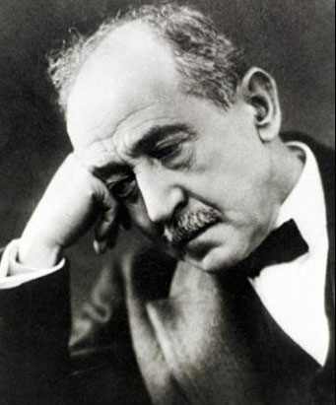

SUMMARY

Ahmad Shawqi was the leading poet and pioneer playwright of the neoclassical period of Arabic literature. Shawqi benefited from a secular education, which allowed him to study law, but more importantly for him, French. Shawqi’s mastery of Arabic and his talents as a poet led him to the Egyptian Khedive’s court as a poet. He found favor with the Khedive and consequently received a fellowship for study abroad in France.

Shawqi returned to the Khedive’s court heavily influenced by his studies abroad. He distinguished himself as an innovator and a rejuvenator of Arabic poetry; however, his efforts to incorporate western influences into his poetry were not favored by the Khedive. As a result, Shawqi excelled in creating poetry on modern themes in the classical tradition, with its complicated meters and rhymes.

Shawqi's poetry championed two causes: Egyptian anti-colonialist sentiments and praise for the Ottoman caliphate. After Egypt’s independence in 1927, Shawqi became a patron of the arts and was honored with the title *Amir al-shu’ara’* ( امير الشعراء )or Prince of Poets, a great honor which recognized his contribution to Arabic literature. In the last eight years of his life, he produced seven plays that were performed in Egypt. Ahmad Shawqi's works represent the best of the neo-classical period that made the leap from pure classical tradition to new poetic forms and genres.

**Ahmad Shawqi**

The *al-Nahda* ( النهضة) or the Arab ‘awakening’ or ‘renaissance’ began in Egypt in the late nineteenth century and extended into the early twentieth century. It was a cultural awakening that expressed itself as a period of reform and modernization that adopted and incorporated Western influences into the mainstream of Arab society.

**Neo-classical Period (**the middle of the nineteenth century until the end of World War I)

Three Egyptian poets, Mahmud Sami al-Barudi (1839-1904), Ahmad Shawqi (1868-1932) and Hafiz Ibrahin (1872- 1932) distinguished themselves during this period. Al-Barudi was the first significant poet of this trend but by far, Ahmad Shawqi was the master. He modeled his poems in the styles of the classical poets, al-Mutannabi, Abu al-'Ala' al-Ma’arri and Abu Tammam. During this period, three main trends emerged in poetry, prose and the theater.

Shawqi served as a court poet to Khedive Tawfiq of Egypt, who awarded him by sending him to France for further studies (1891-1893). During his studies, he was influenced by Alfred de Musset, Alphonse de Lamartine, and Victor Hugo. Upon returning to the court, he attempted to incorporate western influences in his poetry, but was discouraged by the Khedive.

From 1893 until 1914, he served Khedive Abbas Hilmi II as his court poet. He composed odes praising the Khedive and the Alawi dynasty. His lengthy odes utilized the classical metrical forms and were devoted to Egyptian history and the Ottoman Islamic Caliphate. Besides the court, Shawqi's poetry appeared in magazines and newspapers. His *diwan* (collection of poetry), *al-Shawqiyyat* الشوقيات was published in 1898. His works were later collected and published in four volumes (1926, 1930, 1936 and 1943).

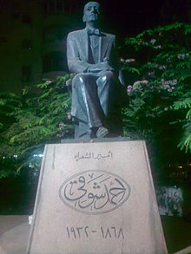

**Statue to Shawqi in Sharm al-Shaykh**

**Shawqi's Second Phase**

Shawqi's poems often followed political, social and historical themes. He championed two causes - Egyptian anti-colonialist sentiments and the Ottoman caliphate. Although he was not a political activist, the power of his Egyptian nationalist poetry and his anti-British rhetoric caused the British to exile him. Shawqi chose Spain for his exile (1915 – 1919) and while there produced his Andalusian odes. His other collected volumes of poetry are topical: volume two, descriptive and amatory poems; volume three, elegies; and volume four, miscellaneous including poems for children.

**Egyptian Independence**

Between 1919 and 1922, Egyptians demonstrated for their independence from Britian. Once independence was achieved, Shawqi as a nationalist became a spokesman for the Egyptian people and a patron of the arts. In 1927, he was awarded the title of ‘Prince of Poets’ (*Amir al-shu'ara'*). In the last eight years of his life, Shawqi produced his verse plays. Two of his most famous verse plays are *Majnun Layla* and *Masra Cleopatra*.

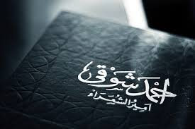

**Ahmad Shawqi, ‘Prince of Poets’**

**Critics and the Romantic Period**

Shawqi's life stretched into the Romantic period (inter WWI - WWII), where emerging Arab poets deemed his poetry to be outmoded and irrelevant to the modern Arab world , as prose writers introduced more Western genres, and poets began experimenting with free verse.

When Shawqi returned from exile he discovered that new poets were influenced by English poets and critics. The Egyptian Romantic school of the *Diwan* led by Abbas Mahmud al-‘Aqqad, the Arab-American School and the *Jama’at Apollo* (*Apollo Group* [an avant-gardiste Romantic movement of Egypt]) in the early 1930s were critics of Shawqi, but despite the criticism, he became president of the *Jama’at Apollo*.

Ahmad Shawqi was a gradualist. His literary progression was evolutionary, not revolutionary. He left behind the ‘School of Shawqi,’ a group of poets who composed in the classical Arabic meters. Classical monorhyme and monometer were slowly discarded in favor of free verse. After Gamal Abdel Nasser's 1952 Egyptian revolution, Shawqi became less popular due to his association with Egypt's royal elites.

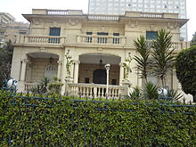

**Ahmad Shawqi Museum**

**Conclusion**

Shawqi’s poems and poetic plays reflected the political currents of the times, defending the caliphate and the Turks. He championed the East against the West and supported Islam, Egyptians, and Arabs in their struggle for independence and self-determination. He called for a revival of the heritage of the Arabs and advocated their cause.

Towards the end of his life, he devoted his works to religious, political, and nationalistic sentiments and issues. Ahmad Shawqi was a true Egyptian patriot whose poetry enhanced the national consciousness of Egypt. His generation embraced pan-Islam in a time of transition and turmoil, when emerging national states were breaking down the traditional structures of the Arab world.

**List of Works**

Shawqi’s works had been published sporadically. In 1982 the Egyptian government celebrated the semi-centennial of his death and published his works in ten volumes.

* *Mawsu’ah al-Shawqiyyah* **الـمـوسـوعـة الـشـوقـيـة،** – (10 vols.) – collected, edited and commented on by Ibrahim al-Abyari completed in 1995 – includes material from Muhammad Sabri’s *al-Shawqiyyat al-majhulah* الشوقيات المجهولة(1961-62) [The Unknown Shawqiyyat) in 2 vols. Of previously unknown works, prose and poems

Further Reading:

Jayyusi, S.Kh. *Trends and movements in modern Arabic poetry*, (Leiden 1977), 1:46.

Shahid, Irfan. ‘Ahmad Shawqi,’ in *Essays in Arabic Literary Biography*, edited by Roger Allen (Harrassowitz 2010), 3:304.

Bibliographical sources

<http://www.bibalex.org/libraries/presentation/static/Shawki.pdf>

<http://www.allamaiqbal.com/publications/journals/review/apr87/8.htm>

descriptions of works

<http://www.sis.gov.eg/En/Templates/Articles/tmpArticles.aspx?ArtID=1292#.VaLaquux2gE> - Egyptian government site

MultiMedia Websites

<http://www.poemhunter.com/ahmad-shawqi/biography/> (for poems w/ English translations)

<https://www.youtube.com/watch?v=iKytMWEbDPM>

[www.transparent.com/arabic](http://www.transparent.com/arabic) Ahmad Shawqi: Expatriation and Nostalgia

(Published on May 15, 2012) - Ahmad Shawqi's ‘Seeniyah’. The poem that he chanted in exile. The part is called ‘ Expatriation and Nostalgia غربة و حنين إلى الوطن

<https://www.youtube.com/playlist?list=PLqdScEb0tqGEp796QVNMKNUyiYvL6hz0g>

For a playlist of 15 videos on Ahmad Shawqi and his poetry

<https://www.youtube.com/playlist?list=PLqdScEb0tqGHivftUOecsui5oD1T2vNBW>

For a playlist of 10 videos of Ahmad Shawqi’s elegiac poetry

Music (Shawqi’s poetry put to music)

<https://www.youtube.com/watch?v=h3IXHCT2yZc>

Oum Kalthoum. Woulida El Houda .

<https://www.youtube.com/watch?v=d3-5eVe_dDc>

Muhammad Abd al-Wahhab – Cleopatra